Do You Feel Lucky?

Roll the dice for your status check about the amazing things you are reading.

What number did you roll? _______ Look at this week's status of reading choices to find out which choice you rolled.

Title of the book, article, or newspaper:

Pages you read:

Complete your status check:

Do You Feel Lucky!/ What did you roll?

# 1
Compose a tweet about a character, event, or idea in your reading. Please make sure the # displays of kernel or nugget of understanding what you are reading.

# 2
Create a review that rates the current chapters or pages you have read today or the book thus far. The review should be out of one to four stars. You must write an explanation of why you are rating these pages or the book thus far.

# 3
What was fun, exciting, or interesting? Create a top 3 list that answers any of these questions. Use Emjoi signs next to each item to let us know how your are feeling about the items on your list. :
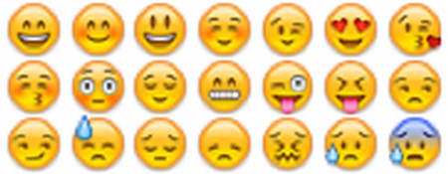

#4
Create a facebook status as a character or about a character, event or idea in what you are reading. The status needs to show you are actively reading and understanding.

# 5
Your choice pick any # 1-4 and complete the task!

# 6
Free write any thoughts you have about what you are reading. Feel free to use Emoji icons to lets us know your feelings about your thoughts.

