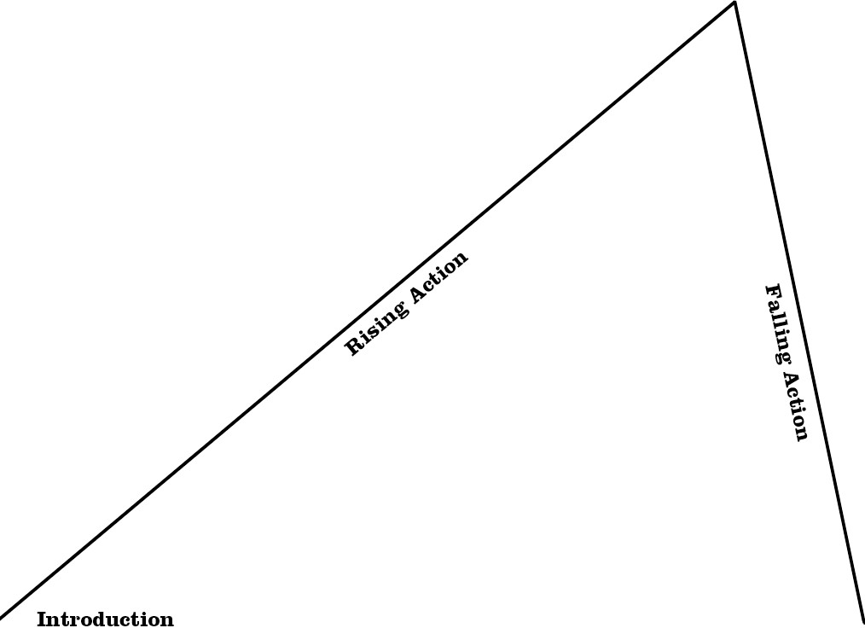••scHOLASTIC

Plot Diagram

Climax

Resolution

http://teacher.scholastic.com

