Revise vs Edit

Revise: Think ARMS | Edit: Think CUPS
Add: *sentences and words  Remove: *unneeded words and sentences  Move: *change a word or sentence placement.  Substitute: *trade words or sentences for others (diction).  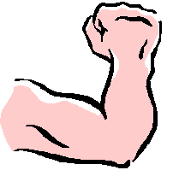 | Capitalization:  *names, places, months, titles, I , ect…  Usage: *match nouns and verbs correctly.  Punctuation: *periods, commas, quotes, question marks  Spelling: *check all words. Use dictionary, thesaurus, or other resource.  